**How to use Processor in JMeter**

**Pre-processor:**

Pre-processor executes some action **before** making Sampler Request.

Consider a simple example: let's say you wanted JMeter to "spider" through website under test, **parse**link(check all links on the page) and **return** the HTML. You would add some action such as "HTML link parser" to your controller before creating an HTTP request.



**Post-processor:**

Post-processor executes some action after making a Sampler Request.

Consider a simple example: JMeter send HTTP request to the web server under test (etc www.google.com) and get the response. You want JMeter to stop the testif the server response is error. You can use the post-processor to do above task as following:

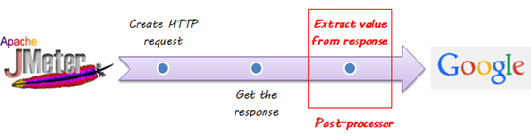

**Processor-Hands on**

This tutorial will show you step-by-step instructions how to use Post-processor in JMeter. Let start with simple test script.

1. JMeter sends HTTP request to the web server under test www.google.com.
2. JMeter gets response from the Google server.
3. If server response is **error**, JMeter will **stop** the test.
4. If server response **OK** (no error), JMeter will **continue** the test.

Here is the **roadmap** of this example:

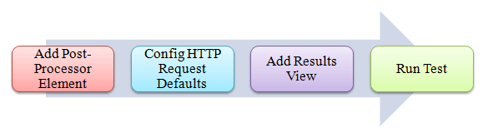

**Pre-condition:**

We **re-use** the Step 1 and Step 2 in article  JMeter Performance Testing.

**Step 1) Add Thread Group**

Right click on the Test Plan and add a new thread group: **Add**-> **Threads (Users)** -> **Thread Group**

But in Thread Group control panel, enter Thread Properties as following:

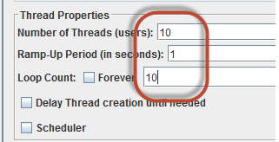

**Step 2) Add JMeter elements**

* Add HTTP request default
* Add HTTP request

We still make JMeter send request http://www.google.com to Google server.

**Step 3) Add Post-Processor Element**

Right Click **Thread Group**->**Add**->**Post Processor**->**Result Status Action Handler**

**Result Status Action Handler** allows the user to stop the thread or the whole test if the user request failed.

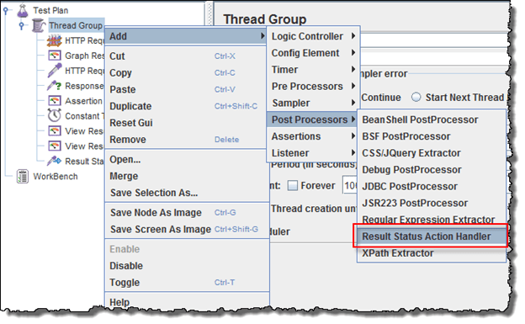

In Result Status Action Handle Pane, choose **Stop Test Now**. This selection will stop the test if JMeter get the error from server response.

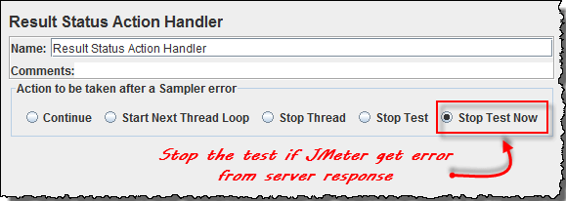

**Step 4) Config the HTTP Request**

Open the HTTP Request Panel. Enter **"abc"** to the Path field.

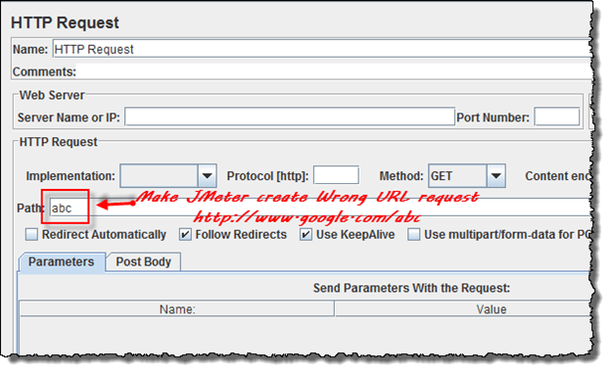

When you enter **"abc"** to the path, JMeter will create URL request to Google server: http://www.google.com/abc. This URL doesn't exist on Google server. It is **wrong** URL request so Google server will return error.

**Step 5) Add View Result Tree**

Right Click **Thread Group**->**Add**-> **Listener**-> **View Result Tree**

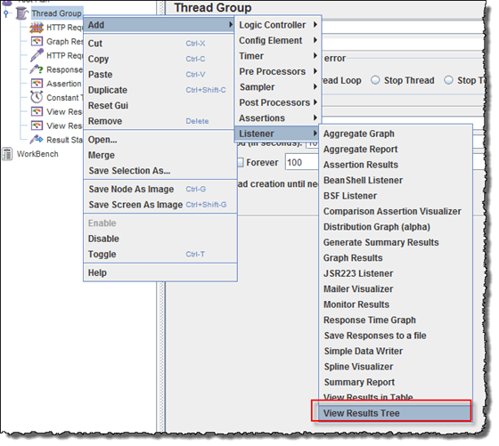

## Step 6) Run Test

Select View Result Tree, press Run button on Menu bar. You will see the **error** response from Google server and the test will stop **with out** completing 100 threads.



Now return to step 4, open the HTTP Request pane, enter "**calendar**" to the pane. It makes JMeter create URL request http://www.google.com/calendar to the Google server. This is **correct** URL request so Google server will return OK (no error).

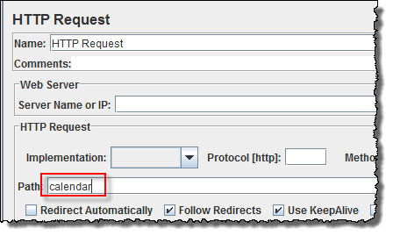

Select View Result Tree, press Run button on Menu bar. You will see the **OK** response from Google server and the test will continue until all 100 threads are complete.

